14. Open the login page with the default language:

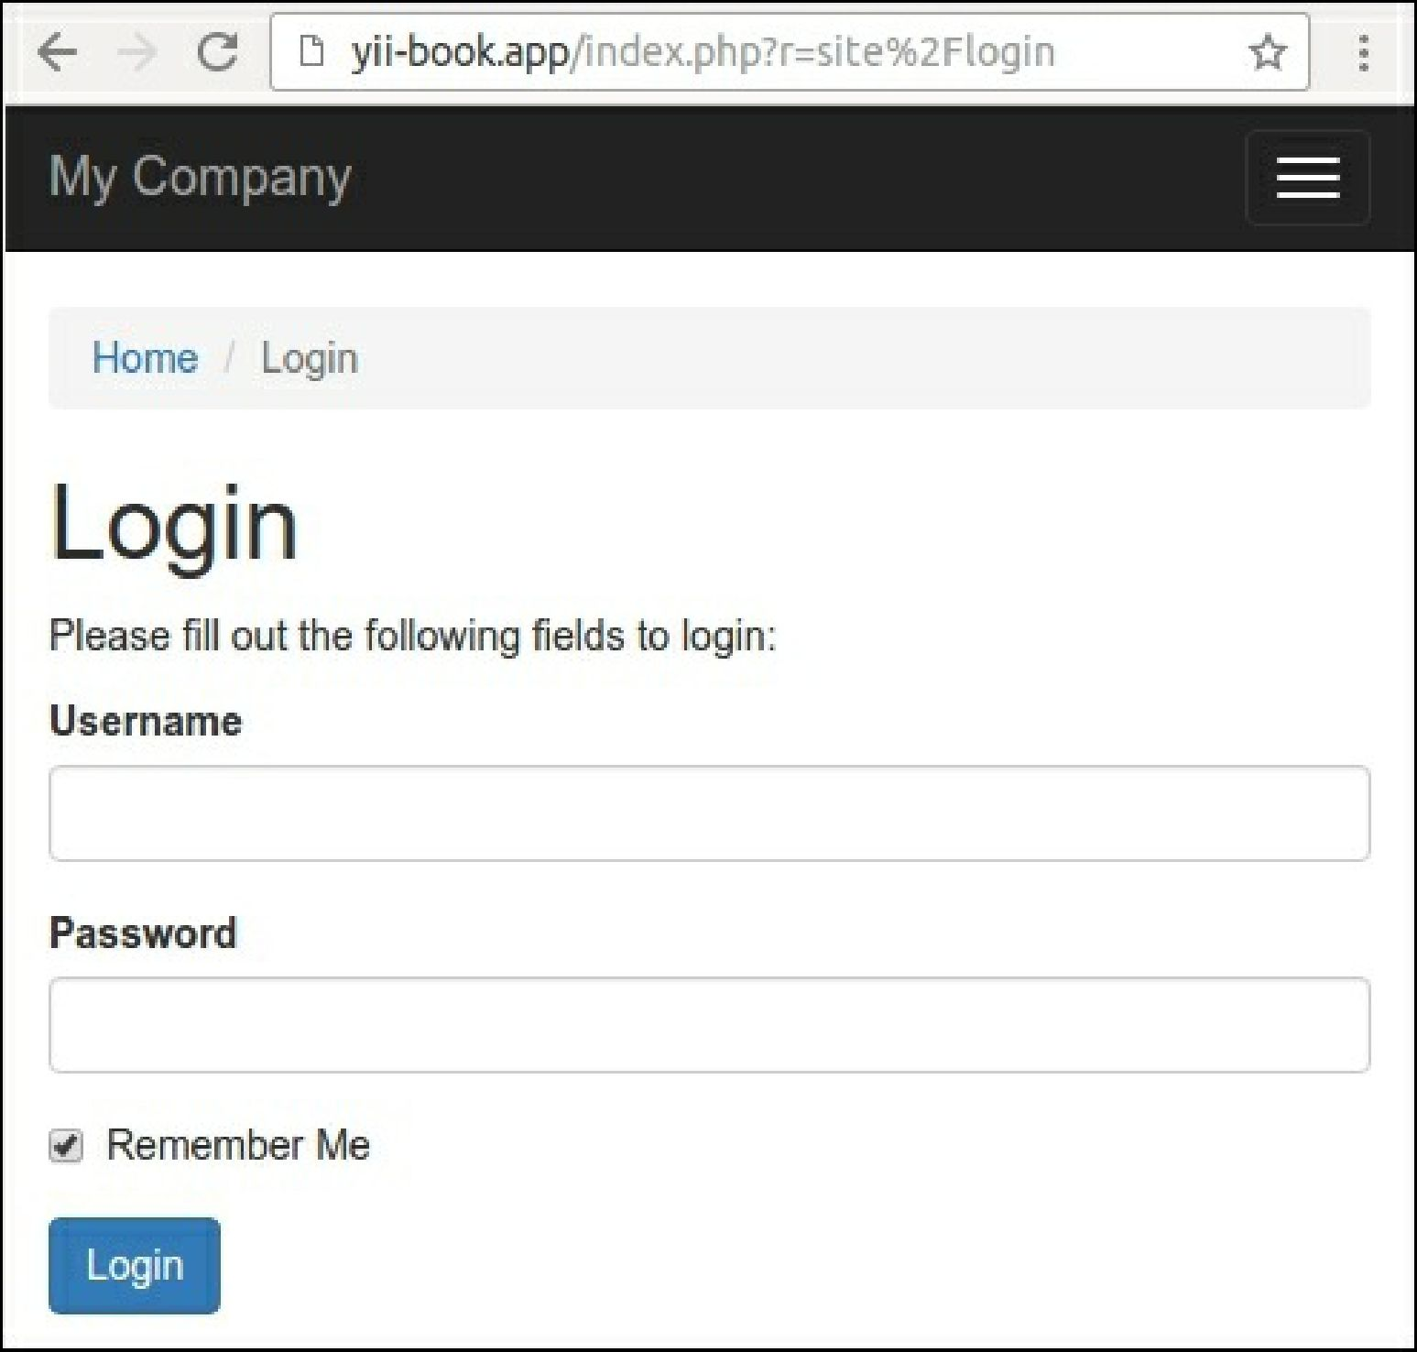

15. Switch the application language to de:

$config = [

'id' => 'basic',

'language' => 'de',

'basePath' => dirname( DIR ),

'bootstrap' => ['log'],

];

Then refresh the login page: